>
Musabaeva Nazym
> restart;
> with(plots);
Warning, the name changecoords has been redefined

> F:=u->cos(u);
> U0:=x->sin(x);
>
rewenie uravnenia
> implicitplot(u-U0(x)=0,x=-1..1,u=-1..1);
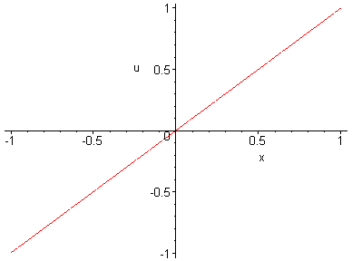
>
rewenie uravnenia u-U0(x-F'(u)*t)=0 pri t=0.5
> implicitplot(u-U0(x-diff(F(u),u)*0.5)=0,x=-1..1,u=-1..1);
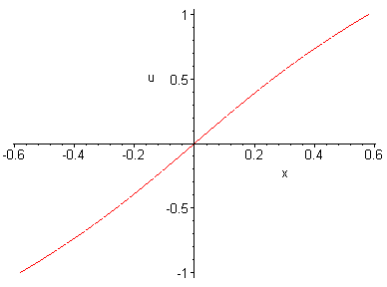
> G:=implicitplot((u-U0(x)=0,x=-1..1,u=-1..1), style=line, color=blue):
> Q:=implicitplot((u-U0(x-diff(F(u),u)*0.1)=0,x=-1..1,u=-1..1),style=line,color=red):
> W:=implicitplot((u-U0(x-diff(F(u),u)*0.2)=0,x=-1..1,u=-1..1),style=line,color=blue):
> S:=implicitplot((u-U0(x-diff(F(u),u)*0.3)=0,x=-1..1,u=-1..1),style=line,color=red):
> H:=implicitplot((u-U0(x-diff(F(u),u)*0.4)=0,x=-1..1,u=-1..1),style=line,color=blue):
> J:=implicitplot((u-U0(x-diff(F(u),u)*0.5)=0,x=-1..1,u=-1..1),style=line,color=red):
> K:=implicitplot((u-U0(x-diff(F(u),u)*0.6)=0,x=-1..1,u=-1..1),style=line,color=blue):
> L:=implicitplot((u-U0(x-diff(F(u),u)*0.7)=0,x=-1..1,u=-1..1),style=line,color=red):
> M:=implicitplot((u-U0(x-diff(F(u),u)*0.8)=0,x=-1..1,u=-1..1),style=line,color=blue):
> N:=implicitplot((u-U0(x-diff(F(u),u)*0.9)=0,x=-1..1,u=-1..1),style=line,color=red):
> display((G,Q,W,S,H,J,K,L,M,N),axes=boxed,scaling=constrained,title='uravnenie');
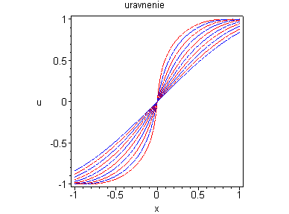
> B1:=(x,t)->solve (u-U0(x-diff(F(u),u)*t)=0,u);
Error, (in plot/options2d) unknown or bad argument: t = -1 .. 1

> B1(5,2);
> valf(%);
> animate([B1(x,t),x,x=-1..1],t=0..1,frames=10);



